**SMART GARDENING SYSTEM AND ITS MONITORING USING IOT**

AUTHOR’S

1. 16BCB0056 – RAVI SHANKAR

Mail: [Chegondiravi.shankar2016@vitstudent.ac.in](mailto:Chegondiravi.shankar2016@vitstudent.ac.in) , SCOPE

1. 16BCB0053 – SRI RAM

Mail: [nadupalli.sriram2016@vitstudent.ac.in](mailto:nadupalli.sriram2016@vitstudent.ac.in), SCOPE

1. 16BCB0101 – SHOURYA MITTAL

Mail: [shourya.mittal2016@vitstudent.ac.in](mailto:shourya.mittal2016@vitstudent.ac.in), SCOPE

1. 17BCI0016 – ROHIT RAJ

Mail: [katururohit.raj2017@vitstudent.ac.in](mailto:katururohit.raj2017@vitstudent.ac.in), SCOPE

1. 16BCE0635 – VENU MADHAV

Mail: [Venkata.venumadhav@vitstudent.ac.in](mailto:Venkata.venumadhav@vitstudent.ac.in), SCOPE



**REQUIREMENTS:**

**HARDWARE REQUIREMENTS**

* ARDUINO – UNO
* MOISTURE SENSOR
* LDR SENSOR (LIGHT SENSOR)
* WIFI-MODULE(ESP8266)
* WATER PUMP
* JUMPER WIRES
* BREAD BOARD

**SOFTWARE REQUIREMENTS**

* ARDUINO SOFTWARE
* GOOGLE CHROME (to access thing speak & freeboard)

**OTHER REQUIREMENTS**

* WIFI CONNECTION
* P.C to access the software’s
* THINGSPEAK ACCOUNT
* WATER SUPPLY
* A SMALL PLANT
* PIPE FOR WATER FLOW
* POWER SUPPLY

IN THINGSPEAK

* First visit “thingspeak.com” and create an account (alternately you can do it in dweet.io)
* Create a new channel with name, description and no of fields are your no of things
* Click on public access and name your sensors (In this case moisture and light sensors)
* Note down the api key of your channel from view your channel and read api keys section

IN ARDUINO SOFTWARE

* Go to file => preferences and add <http://arduino.esp8266.com/versions/2.4.2/package_esp8266com_index.json> this link in additional board managers and click OK

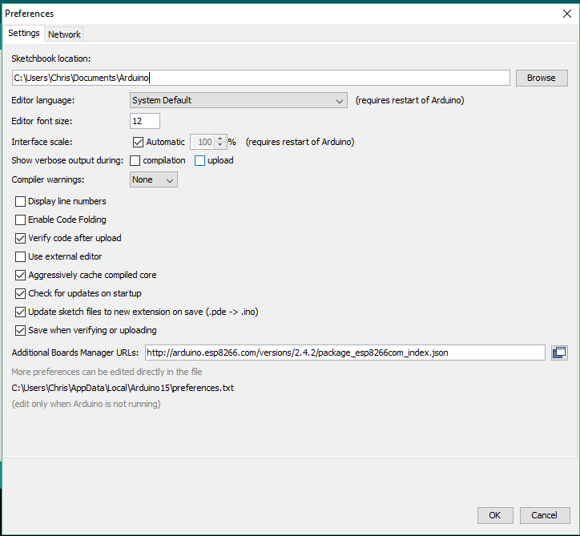

* Now go to TOOLS => BOARDS => BOARDS MANAGER => search for 8266 and install esp8266 by esp8266 community

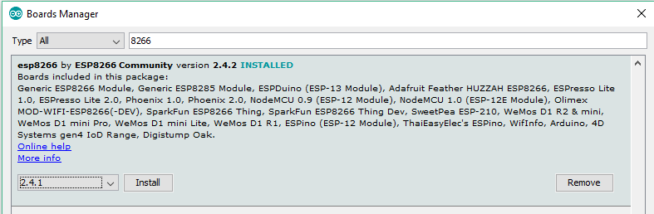

* Now go to sketch=> manage libraries => include libraries => search for thingspeak and install thingspeak by mathworks

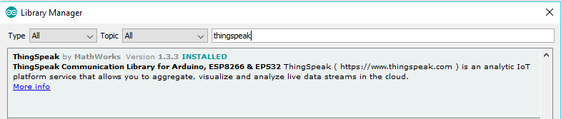

CONNECTING & TESTING THE WIFI MODULE :

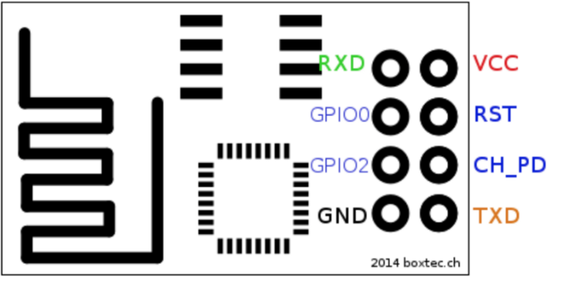

* Above diagram shows the interface of esp8266 module. Connect GND to ground, Vcc & CHPD to +3.3v of Arduino Output power supply and connect rxd to rx of Arduino and txd to tx of the Arduino to communicate with the Wi-Fi module for testing serially(This communication is going between the P.C and Wi-Fi and Arduino if just used as serial connector I this case)
* Set The board in Arduino software to esp8266(Tools => board => Generic ESP8266 module) and Now try these commands to test your module in serial monitor (Tools => Serial monitor) of Arduino software

Type: AT

Response: OK

Type: AT+CWJAP?

Response: It will list all the wifi modules followed by OK

Type: AT+CWJAP=”WIFI_NAME”,”WIFI_PASSWORD”

Response: WIFI CONNECTED

WIFI GOT IP

OK

**Note:** In the entire coding part spaces for the Wi-Fi module code part is ‘space sensitive’. So please don’t give any extra spaces. If you do so it won’t work. Type exactly the same without giving or leaving any spaces (For esp8266 part)

* If this works you can confirm that your Wi-Fi module is working
* To test the sensors, go to examples in Arduino software and test for the output by connecting them accordingly
* After Testing and if every sensor/module is working fine then Let’s Get Started

**CONNECTIONS**

* Connect the circuit as shown in the figure
* We are already using the serial ports with serial monitor in Arduino software (P.C). so we can use the serial monitor library and we can define another serial ports (Say 11,10 for Rx and Tx)
* Give their respective power supplies for the sensors and with the WI-FI module the only change with connection is connect the 11th Pin (New Tx of Arduino) with Rx and 10th Pin (New Rx of Arduino) with Tx of the Arduino

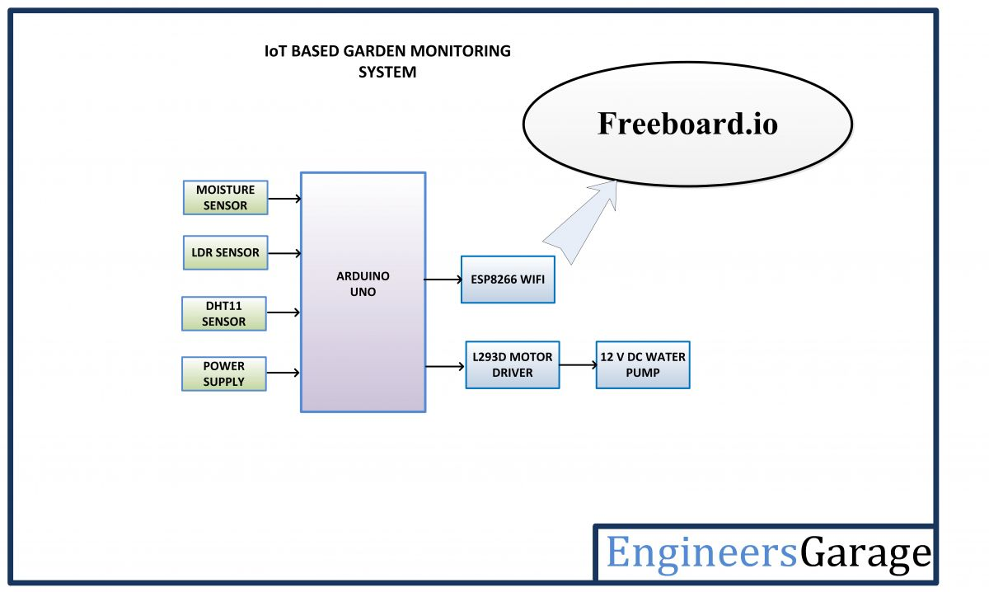

12

A1

A0

10

11

5v water pump

**Note:** Here we are connecting oppositely because Arduino is going o communicate with the Wi-Fi module and not the P.C, hence we have to connect normally

* Give the respective power supplies for all the modules and connect the analog pin of moisture to A0 and analog pin of LDR to A1 of the module
* Connect the water pump to 6th pin to pump the water when the sensor detects it
* Give water source to the water pump via pipes and keep the other end in the soil
* Keep the LDR sensor in open atmosphere and dip the Moisture sensor pin in the soil
* Upload the Arduino code and then You are **ALMOST DONE!**

**CODE:-**

#include <SoftwareSerial.h>

#define pump 12

#define led 13

#define MOS A0

#define LDR A1

int mos_val;

int lig_val;

String AP = "chris";

String PASS = "";

String API = "DPFZR0CGYU5SI8T5";

String HOST = "api.thingspeak.com";

String PORT = "80";

int countTrueCommand = 1;

int countTimeCommand;

boolean found = false;

SoftwareSerial esp8266(10, 11);

void setup() {

Serial.begin(9600);

esp8266.begin(115200);

pinMode(led, OUTPUT);

pinMode(pump, OUTPUT);

sendCommand("AT", 5, "OK");

sendCommand("AT+CWMODE=3", 5, "OK");

sendCommand("AT+CWJAP=\"" + AP + "\",\"" + PASS + "\"", 20, "OK");

}

void loop() {

String getData = "GET /update?api_key=" + API + "&field1=" + String(read_mos()) + "&field2=" + String(read_lig());

sendCommand("AT+CIPMUX=1", 5, "OK");

sendCommand("AT+CIPSTART=2,\"TCP\",\"" + HOST + "\",80", 15, "OK");

sendCommand("AT+CIPSEND=2," + String(getData.length() + 4), 10, ">");

esp8266.println(getData);

countTrueCommand++;

delay(10000);

sendCommand("AT+CIPCLOSE", 5, "OK");

if (mos_val > 800){

digitalWrite(pump, HIGH);

delay(5000);

digitalWrite(pump, LOW);

}

if (lig_val < 780) {

digitalWrite(led, HIGH);

}

else {

digitalWrite(led, LOW);

}

Serial.println();

}

int read_lig() {

lig_val = analogRead(LDR);

Serial.print("Light value: ");

Serial.println(lig_val);

return lig_val;}

int read_mos() {

mos_val = analogRead(MOS);

Serial.print("Moisture value: ");

Serial.println(mos_val);

return mos_val;}

void sendCommand(String command, int maxTime, char readReplay[]) {

Serial.print(countTrueCommand);

Serial.print(". at command => ");

Serial.print(command);

Serial.print(" -> ");

while (countTimeCommand < (maxTime * 1)) {

esp8266.println(command);//at+cipsend

if (esp8266.find(readReplay)) //ok

{

found = true;

break;

}

countTimeCommand++;

}

if (found == true)

{

Serial.println("OK");

countTrueCommand++;

countTimeCommand = 0;

}

else {

Serial.println("Fail");

countTimeCommand = 0;

}

found = false;

}

* Save this code in your Arduino software
* Select the board as Arduino Uno and Select the correct port from the ports
* Compile the code and upload your code to the Arduino Uno board after all the connections
* The moisture and Light intensity values will be updated for every 15 seconds to the THING SPEAK website and you can share the link to anyone you want
* If you want to show it in a more fashionable way you can link it to freeboard.io
* To do that create a freeboard.io account and create a data source and select a json type and select Gauge type in widgets add the link in the Value of the widget
* You can use a simple mobile application to view your data of the dashboard and graphical view can also be seen via thing speak

**RESULTS:**

